*Question 1:*

*Output:*

*Question 2:*



*Output:*

*Question 3:*

*Output:*

*Question 4:*

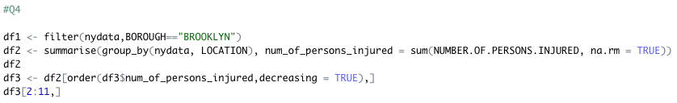

*Output:*

*Question 5:*

*Output:*

*Question 6:*

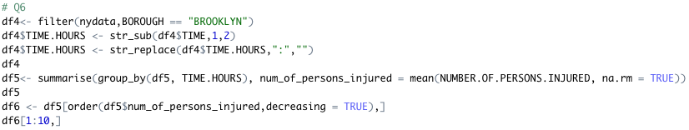

*Output:*

* The TIME.HOURS represents the hour in a day.
* At the time 23:00 in a day had the highest mean number of persons injured.

*Question 7:*

*Output:*

* The above table shows the number of person injured, and the number of persons killed and how do they vary according to each year for all the boroughs.
* Nearly it is the total number of persons injured = 150 * the total number of persons killed in each year for all the boroughs.